Contents

INTRODUCTION 2

AIM 2

THEORY 2

MATERIALS REQUIRED 4

OBSERVATION 5

CALCULATION 5

COMPARISION WITH THEORY 6

CONCLUSION 6

ADDITIONAL DISSCUSSION 7

REFRENCES 7

## INTRODUCTION

*The Charpy Impact Test is a standardized method to evaluate the impact resistance and energy absorption capacity of materials under sudden dynamic loading, crucial for components exposed to shock loads, such as locomotive wheels and connecting rods. This test involves fracturing a V-notched specimen (typically 55x10x10 mm with a 45° notch) using a pendulum hammer, measuring the energy difference between initial and residual swing to determine notch impact strength. It assesses material toughness, aiding in quality control and material selection in engineering applications. The Charpy test, alongside the Izod test, provides critical insights into brittle-ductile transitions and structural integrity, ensuring safety and reliability in high-stress environments.*

## AIM

*To determine the impact strength and energy absorption capacity of a V-notched mild steel specimen using a pendulum hammer, assessing its toughness under sudden dynamic loading as per Charpy test standards.*

## THEORY

#### CHARPY IMPACT TEST

*Charpy Impact Test determines a material's toughness by fracturing a V-notched specimen with a pendulum hammer. It quantifies absorbed energy (joule/mm²) to assess notch impact strength and fracture behaviour (ductile/brittle). Widely used in engineering to evaluate structural materials (e.g., steels) for shock resistance in applications like bridges, pipelines, or machinery.*

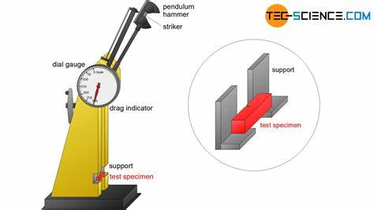

#### MATERIAL TOUGHNESS

*Material toughness is a material’s capacity to absorb energy and deform plastically before fracture, balancing strength, and ductility. Measured via impact tests like Charpy, it determines resistance to sudden loads, differentiating ductile (energy-absorbing) from brittle fractures. Vital for structural applications—bridges, pipelines, machinery—where impact resistance ensures safety.*

#### NOTCH SENSTIVITY

*Notch sensitivity describes a material’s susceptibility to fracture due to stress concentration at notches, cracks, or geometric discontinuities. Materials with high notch sensitivity (e.g., brittle metals, ceramics) fail abruptly under stress at notches, while ductile materials (e.g., mild steel) redistribute stress, resisting fracture. This property is critical in engineering design, as real-world components often contain notches from machining, wear, or design features. The Charpy test quantifies this by measuring energy absorption in notched specimens, revealing how stress amplification impacts fracture behaviour. Factors like material microstructure, temperature, and loading rate influence notch sensitivity, guiding material selection for applications prone to impact or fatigue, such as automotive parts or structural frameworks.*

#### BRITTLE VS DUCTILE FRACTURE BEHAVIOUR

*Brittle fracture occurs when a material breaks suddenly with minimal plastic deformation, exhibiting flat, crystalline surfaces (e.g., glass). Ductile fracture involves significant deformation (necking, stretching) before failure, leaving fibrous, dimpled surfaces (e.g., copper). The Charpy test differentiates these behaviours by measuring absorbed energy: low energy indicates brittleness (rapid crack propagation), high energy suggests ductility (plasticity absorbs impact). Notch sensitivity and temperature influence transitions between these modes.*

#### ENERGY CONSERVATION PRINCIPLES

*Energy conservation principles dictate that energy cannot be created or destroyed but transforms between forms. In the Charpy test, the pendulum’s initial gravitational potential energy converts to kinetic energy during its swing. Upon impact, part of this energy fractures the specimen (absorbed energy), while the remainder lifts the pendulum. The absorbed energy (E₁−E₂) quantifies material toughness, adhering to energy conservation, with minor losses (e.g., friction, sound, heat) typically negligible in standardized setups.*

#### STRESS CONCENTRATION AND FRACTURE MECHENICS

*Stress concentration arises when stress localizes sharply around geometric discontinuities (e.g., notches, cracks), amplifying applied loads and initiating failure. Fracture mechanics studies how such flaws propagate under stress, analysing crack growth using parameters like stress intensity factors. It predicts material failure, guiding designs to mitigate catastrophic breaks in structures, pipelines, or machinery by understanding brittle vs. ductile fracture behaviours.*

#### TEMPERATURE DEPENDENCE BEHAVIOUR

*The Charpy impact test reveals how materials exhibit temperature-dependent fracture behaviour. Many metals, like steel, undergo a ductile-to-brittle transition: at lower temperatures, they fracture with minimal deformation (brittle), absorbing less energy, while at higher temperatures, they deform plastically (ductile), absorbing more energy. This transition temperature is critical for applications in cold environments (e.g., pipelines, ships) to avoid catastrophic failures. Understanding this behaviour ensures materials are selected or treated to maintain toughness under operational temperature ranges.*

## MATERIALS REQUIRED

*Charpy Impact Testing Machine: Pendulum hammer (18.7 kg weight, 1600 mm swing diameter), supports (40 mm span), dial/digital energy scale (2 J least count), and release mechanism.*

*Test Specimens: Mild steel bars (standard dimensions: 55 × 10 × 10 mm) with a V-notch (45° angle, 2 mm depth).*

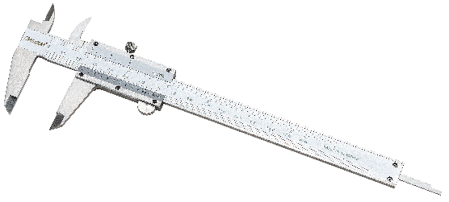

*Measurement Tools: Vernier calliper (to verify specimen dimensions).*

*Specimen Fixture: Alignment tool to position the specimen centrally on the supports.*

*Safety Gear: Safety goggles, gloves, and protective barriers (to shield from flying debris).*

*Calibration Tools: Calibration certificate or standard reference specimen for machine verification.*

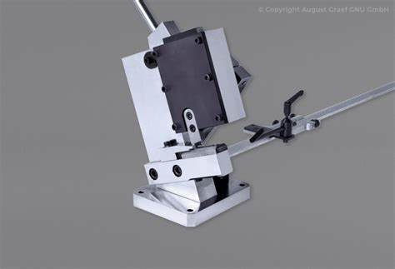

*Notching Machine: For preparing notched specimens if pre-cut samples are unavailable.*

*Fracture Analysis Tools: Magnifying glass or microscope (to examine fracture surfaces post-test).*

*Liquid nitrogen (LN₂) is a cryogenic fluid (−196°C/−320°F) used in material testing to study low-temperature behaviour, such as the ductile-to-brittle transition in metals (e.g., steels). By cooling specimens to subzero temperatures, it reveals how materials become brittle under impact loads, critical for applications like Arctic pipelines, cryogenic storage, or aerospace components. Safety protocols (gloves, goggles, ventilation) are essential due to risks of frostbite and rapid vaporization. In Charpy tests, LN₂-cooled specimens help assess notch sensitivity and fracture mechanics in extreme environments.*

## OBSERVATION

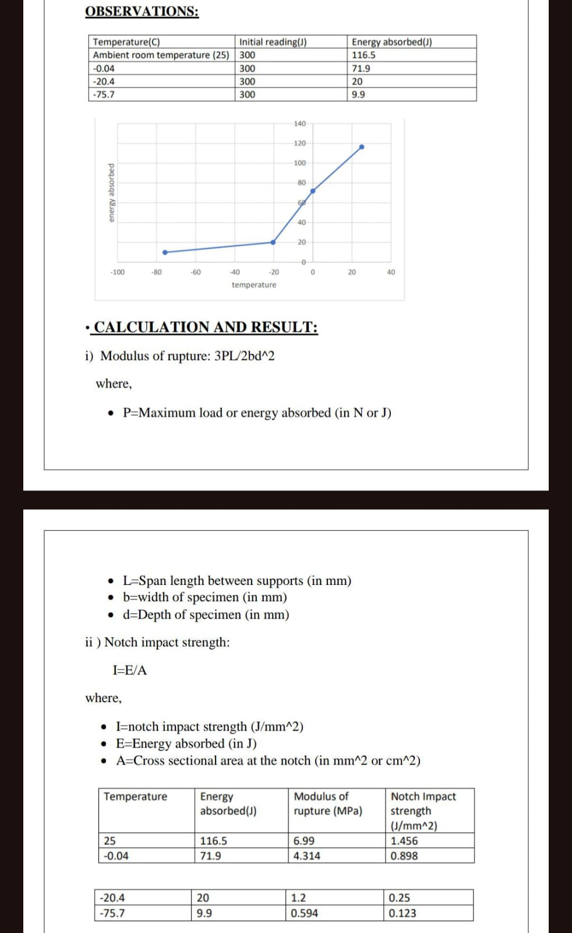

## CALCULATION





## COMPARISION WITH THEORY

*The experimental results align with theoretical principles of the Charpy Impact Test, particularly the ductile-to-brittle transition and temperature-dependent fracture behaviour. At ambient temperature (25°C), the specimen absorbed 116.5 J of energy, with a notch impact strength of 1.456 J/mm², reflecting ductile fracture behaviour characterized by plastic deformation and high energy absorption. As temperatures decreased to subzero levels (-20.4°C and -75.7°C), energy absorption sharply declined (20 J and 9.9 J, respectively), and notch impact strength dropped to 0.25 J/mm² and 0.123 J/mm². This transition to brittle fracture at lower temperatures is consistent with the theory that reduced thermal energy restricts atomic mobility, increasing notch sensitivity and promoting rapid crack propagation. The modulus of rupture also decreased from 6.99 MPa at 25°C to 0.594 MPa at -75.7°C, confirming that materials lose fracture resistance as they transition to brittleness. This aligns with the concept of stress concentration at the notch, where localized stresses amplify under dynamic loading, accelerating failure. The steep decline in energy absorption between -0.04°C and -20.4°C suggests the onset of the ductile-brittle transition zone, critical for applications in low-temperature environments. These results validate the energy conservation principle: absorbed energy (E₁−E₂) directly correlates with material toughness and temperature. The experiment reinforces theoretical models of dynamic loading, notch sensitivity, and structural integrity, emphasizing the importance of temperature in material selection for engineering applications.*

## CONCLUSION

*The Charpy Impact Test results demonstrate a clear ductile-to-brittle transition in mild steel as temperature decreases. At ambient temperature (25°C), the specimen exhibited ductile fracture behaviour, absorbing 116.5 J of energy with a notch impact strength of 1.456 J/mm², reflecting high material toughness and plastic deformation. However, at subzero temperatures (-20.4°C and -75.7°C), energy absorption drastically dropped to 20 J and 9.9 J, respectively, with notch impact strength plummeting to 0.25 J/mm² and 0.123 J/mm². This sharp decline confirms increased brittleness and reduced stress redistribution capacity at low temperatures. The modulus of rupture also decreased from 6.99 MPa (25°C) to 0.594 MPa (-75.7°C), indicating reduced fracture resistance under dynamic loading. These findings align with the theory of temperature-dependent notch sensitivity, where stress concentration at the V-notch accelerates crack propagation in brittle states. The abrupt energy reduction between -0.04°C and -20.4°C highlights the critical ductile-brittle transition zone, essential for applications in cold environments (e.g., Arctic pipelines, cryogenic systems). This experiment validates the importance of temperature in material selection and design, emphasizing that materials suitable for room-temperature applications may fail catastrophically under subzero conditions. The results reinforce the necessity of impact testing for ensuring structural integrity in diverse operational environments.*

## ADDITIONAL DISSCUSSION

#### DYNAMIC LOADING RESPONSE

*Dynamic loading response describes how materials behave under sudden, high-speed forces (e.g., impacts) compared to static loads. Rapid strain rates alter properties: materials may exhibit higher strength but lower ductility, leading to brittle fractures. Energy absorption mechanisms, deformation patterns, and crack propagation rates differ significantly, influencing design choices for structures or components exposed to shocks, such as vehicles or machinery.*

#### QUANTITATIVE METRICS

*Quantitative metrics in the Charpy impact test include absorbed energy (initial minus residual energy in joules), notch impact strength (absorbed energy divided by the specimen’s cross-sectional area at the notch, in joule/mm²), and modulus of rupture (rupture energy per specimen volume, in joule/mm³). These values assess a material’s resistance to dynamic loading, stress concentration effects at notches, and fracture behaviour, aiding in material selection and structural design for applications requiring impact resistance.*

#### MATERIAL ANISOTROPY

*Material anisotropy refers to directional dependence of a material’s mechanical properties, such as strength or toughness, influenced by internal structures like grain orientation. In metals, processes like rolling or forging align grains, creating varied responses to stress. During Charpy testing, specimens oriented parallel to rolling direction may absorb more energy than those perpendicular, highlighting anisotropy’s role in fracture behaviour. Engineers must consider this when designing components subjected to multi-directional loads to prevent unexpected failures. Testing across orientations ensures accurate assessment of real-world performance.*

#### FAILURE ANALYSIS

*Failure analysis involves examining fractured materials to determine the cause and mechanism of failure, such as identifying brittle or ductile fracture modes through surface characteristics (e.g., fibrous vs. crystalline appearance). It assesses factors like notch sensitivity, stress concentration, and material defects, aiding in improving design, material selection, and manufacturing processes to prevent future failures in critical engineering applications.*

## REFRENCES

* [*https://en.wikipedia.org/wiki/Charpy_impact_test*](https://en.wikipedia.org/wiki/Charpy_impact_test)
* [*https://www.sciencedirect.com/topics/engineering/charpy-impact-test*](https://www.sciencedirect.com/topics/engineering/charpy-impact-test)
* [*https://law.resource.org/pub/in/bis/S10/is.1757.1988.pdf*](https://law.resource.org/pub/in/bis/S10/is.1757.1988.pdf)
* [*https://www.testronixinstruments.com/blog/charpy-impact-test-principles-steps-and-procedures/*](https://www.testronixinstruments.com/blog/charpy-impact-test-principles-steps-and-procedures/)